**File Management System**



By

P B Aakash Sai Raj (121910310021)

D Anisha Rao (121910310002)

**Declaration**



We, the undersigned solemnly declare that the report of the project work entitled “File Management System”, is based on our own work carried out during the course of our study under the supervision of Sri Venakata Praneel Ankireddy.

PB Aakash Sai Raj

121910310021

D Anisha Rao

121910310002

**Database tables:**

**User Table:**

|  |  |  |  |  |
| --- | --- | --- | --- | --- |
| Field | Datatype | Default | Key | Extra |
| id | integer | NOT NULL | PRIMARY KEY | AUTO INCREMENT |
| password | varchar(128) | NOT NULL |  |  |
| last_login | datetime | NULL |  |  |
| is_superuser | bool | NOT NULL |  |  |
| username | varchar(150) | NOT NULL |  |  |
| last_name | varchar(150) | NOT NULL |  |  |
| email | varchar(254) | NOT NULL |  |  |
| is_staff | bool | NOT NULL |  |  |
| is_active | bool | NOT NULL |  |  |
| date_joined | datetime | NOT NULL |  |  |
| first_name | varchar(150) | NOT NULL |  |  |

**Upload_document Table:**

|  |  |  |  |  |
| --- | --- | --- | --- | --- |
| Field | Datatype | Default | Key | Extra |
| id | integer | NOT NULL | PRIMARY KEY | AUTO INCREMENT |
| title | varchar(20) | NOT NULL |  |  |
| description | text | NULL |  |  |
| file_path | varchar(20) | NULL |  |  |
| user_id | integer | NOT NULL | References “id” from User table |  |
| date_created | datetime | NOT NULL |  |  |
| date_updated | datetime | NOT NULL |  |  |

**Data Flow diagram:**

**1)Dataflow of user login:**

**2)Dataflow of user registration:**

**3)Dataflow of uploading documents:**

**Technologies used for backend:**

* JavaScript
* PHP
* Django
* MySQL

**Django:**

A high-level Python web framework called Django enables the quick creation of safe and dependable websites. Django, which was created by seasoned programmers, handles a lot of the hassle associated with web development, allowing you to concentrate on developing your app without having to invent the wheel. It is open source and free, has a strong community, excellent documentation, and a variety of free and paid support options.

A framework for deadline-driven perfectionists is Django Python. It allows you to create better Web apps with less code and in much less time. Django is renowned for emphasizing automation. Additionally, it adheres to the DRY (Don't Repeat Yourself) maxim.

Originally designed for content management systems, Django is currently utilized by many different types of online applications. This is due to its automatic admin interface generation, automatic database generation, automatic DB access layer, and templating. A web server is also available for use in development.

Instagram, Mozilla, Pinterest, The Washington Times are large firms that use Django Python. In fact, the first thing that springs to mind when we hear the words "framework" and "Python" is Django.

**MySQL:**

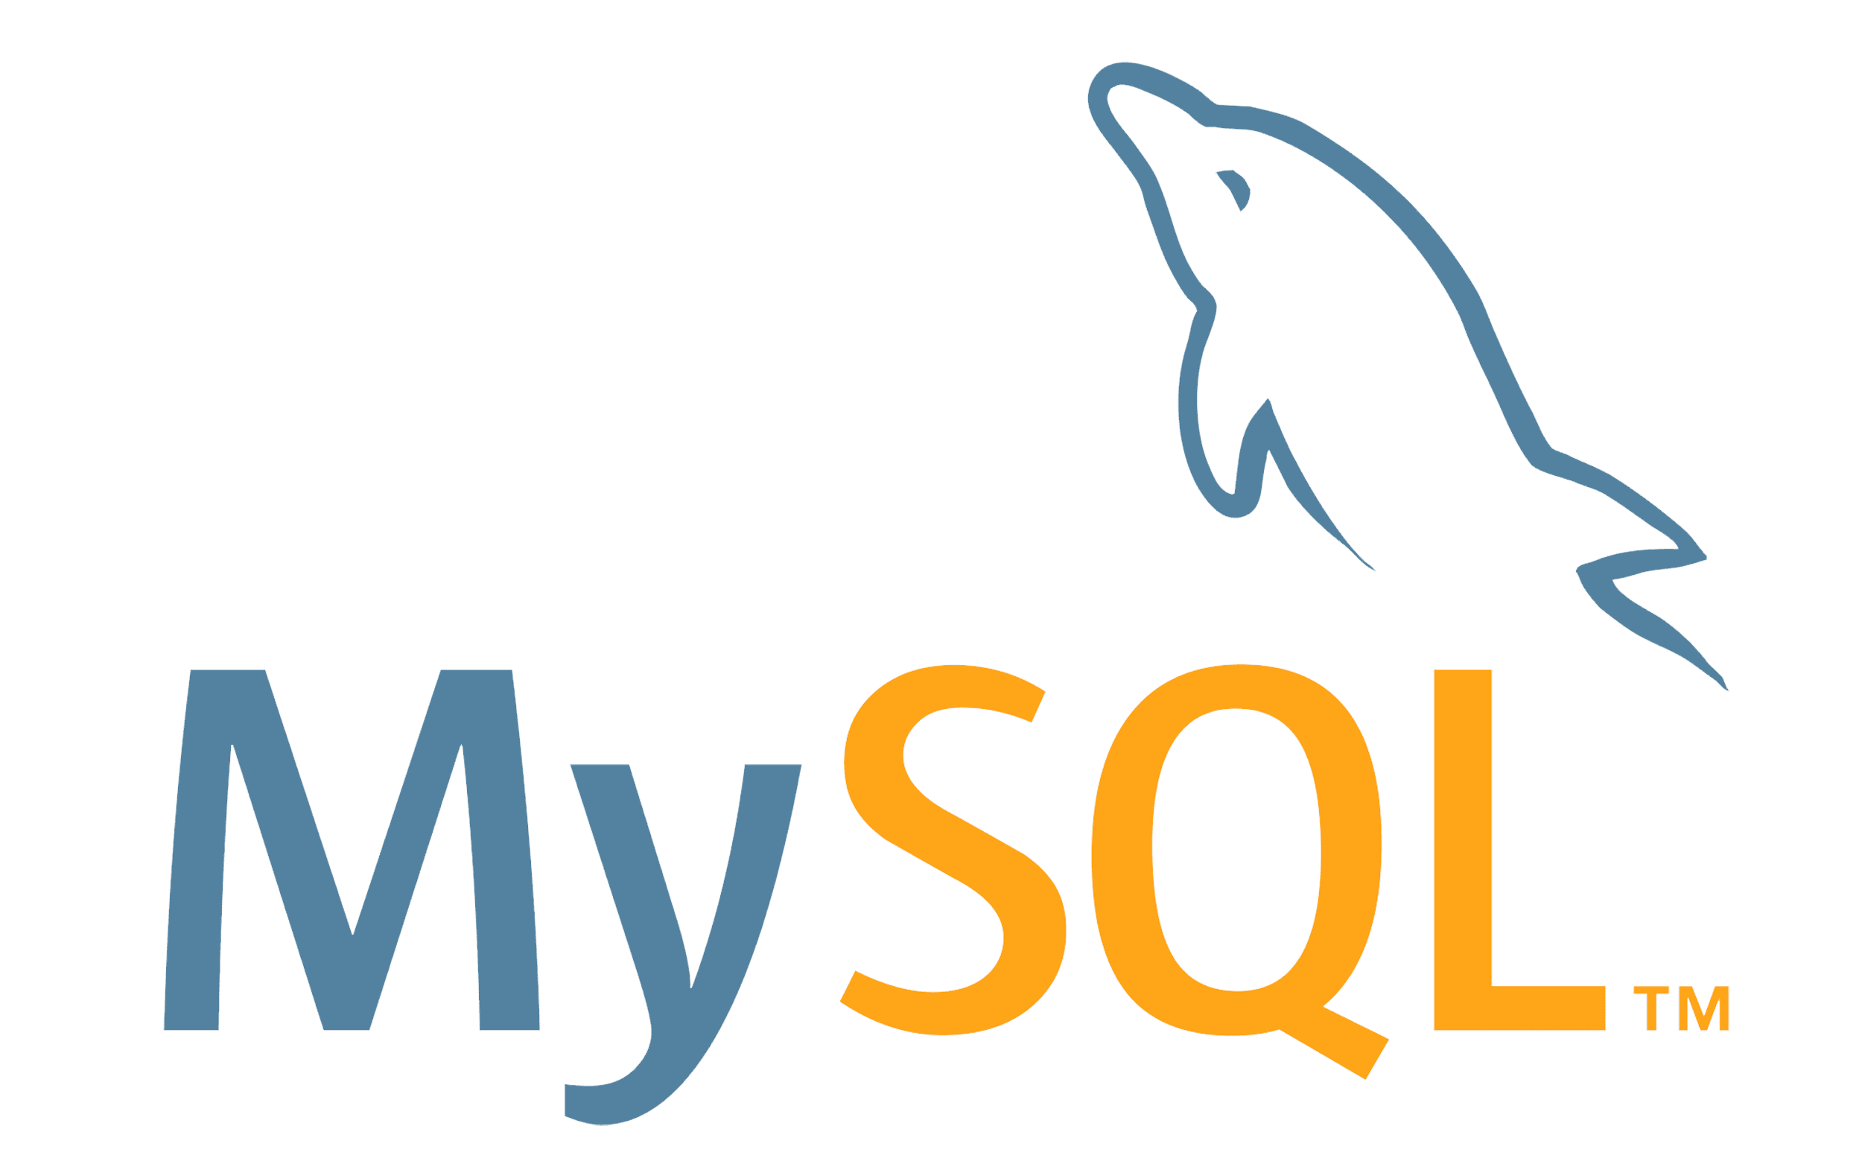

The second-most popular open-source relational database management system in the world is MySQL (RDBMS). It is named after My Widenius, daughter of co-founder Michael Widenius. SQL, or Structured Query Language, is the abbreviation. The MySQL development project has released its source code under a number of private agreements as well as the GNU General Public License. One for-profit corporation, the Swedish company MySQL AB, which is now owned by Oracle Corporation, was both the owner and sponsor of MySQL. A crucial part of the widely used LAMP open source web application software stack (and other "AMP" stacks), MySQL is a well-liked database for usage in online applications.The term "Linux, Apache, MySQL, Perl/PHP/Python" is referred to as LAMP. MySQL is frequently used in free-software, open-source projects that need a robust database management system. There are various paid editions that are available for commercial usage and provide more capabilities.

**JavaScript :**

JavaScript is a dynamic computer programming language. It is lightweight and most commonly used as a part of web pages, whose implementations allow client-side script to interact with the user and make dynamic pages. It is an interpreted programming language with object-oriented capabilities.

JavaScript was first known as LiveScript, but Netscape changed its name to JavaScript, possibly because of the excitement being generated by Java. JavaScript made its first appearance in Netscape 2.0 in 1995 with the name LiveScript. The general-purpose core of the language has been embedded in Netscape, Internet Explorer, and other web browsers.

**PHP:**

A little open source effort at first, PHP grew as more users realised how beneficial it was. In 1994, Rasmus Lerdorf released PHP's initial iteration.PHP stands for "PHP: Hypertext Preprocessor," a recursive acronym.HTML includes the server-side scripting language PHP. It is used to develop full e-commerce sites as well as manage dynamic content, databases, and session monitoring. Numerous well-known databases, including MySQL, PostgreSQL, Oracle, Sybase, Informix, and Microsoft SQL Server, are connected with it.

Particularly when compiled as an Apache module on the Unix side, PHP runs pleasantly quickly. Once it is running, the MySQL server executes even the most sophisticated queries with enormous result sets in a lightning-fast manner.

Thank You